**Planning Meeting Minutes**

Date: December 25, 2023

Time: 7:00 PM - 9:00 PM

Location: Discord

**Attendees**

* 21127712 – Le Quang Truong Leader, Developer
* 21127443 – Tran Ngoc Truong Thinh Developer, Business Analyst
* 21127331– Nguyen Van Tuan Kiet Developer, Design
* 21127315 – Nguyen Gia Khanh Developer, Tester
* 21127606 – Bui Nguyen Hanh Developer, Tester

**Agenda**

* Project Status Update
* Review last sprint result
* Discussion
* Action Items and Next Steps

**Discussion**

Project planning

* Trường hosted the meeting, created documents and summarized the team's ideas.
* Trường has specified main functions that need to be tested
* Trường has scheduled meetings to conduct formal tests.
* There’s no specific task for each member, everyone in the team has to write test cases and test simultaneously, report all defects found in the process.

**Decisions**

1. Jira tasks have been assigned to team members to provide basic guidelines for the testing process, these are not actual tasks.
2. Tasks are assigned to each team member on Jira.
3. All team members have to contribute in the test process.

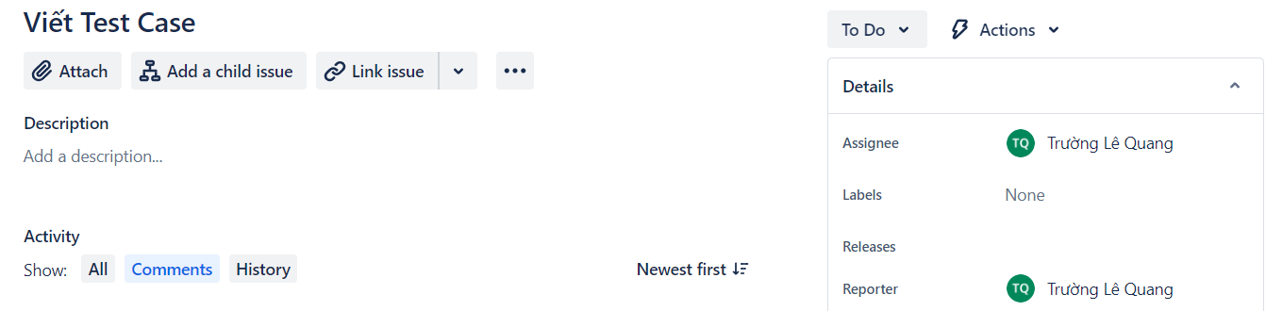

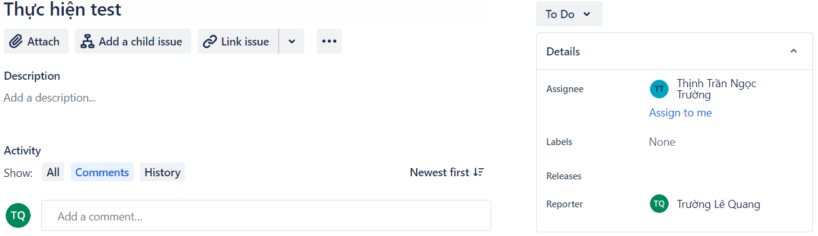

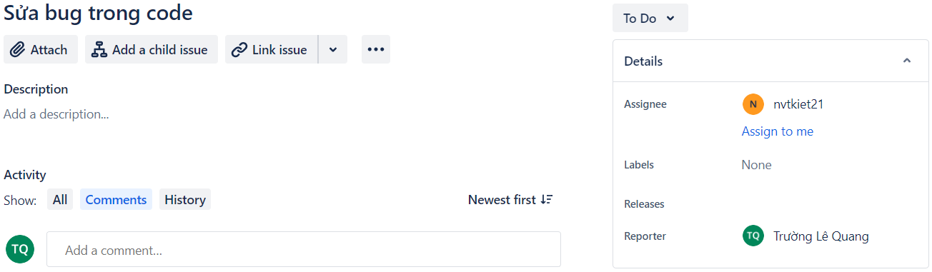

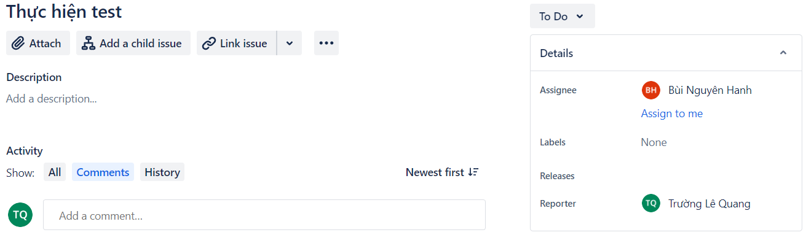

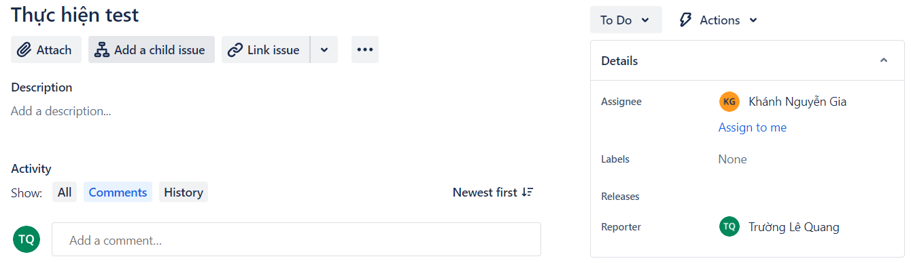

**Next Steps**

1. Trường will announce the team when a change is needed.
2. Each team member proceeds to do regular tests before the next meeting.

**Adjournment**

The meeting concluded at 9:00 PM. The next meeting is scheduled for Dec 27, 2023, at 7:00 PM.

Prepared by:

Le Quang Truong(Team lead)